Dermoid cyst
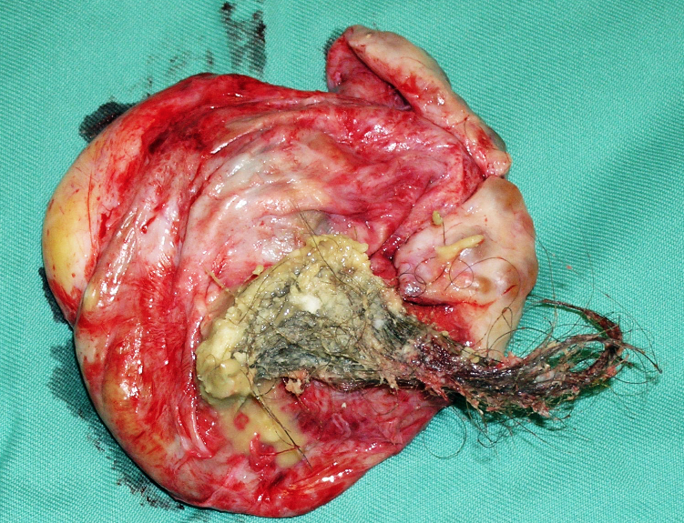
Figure 1 : Dermoid cyst
Dr Sevellaraja Supermaniam
Introduction
Whenever I tell a patient that the cyst in her ovary contains hair, teeth, bone, brain tissue etc, I usually get a confused look. The first question I will be asked is “how can there be hair in a cyst in my ovary in my tummy?”. I have always had difficulties explaining how these structures got into the ovary. Some of the common questions asked are:
- What is a dermoid cyst?
- What age does it occur?
- What are the symptoms of a Dermoid cyst?
- How is it diagnosed?
- Can a dermoid cyst be a cancer?
- When is surgery required?
- How is surgery performed?
- Will it recur after surgery?
- Is my ovary destroyed by removal of the cyst?
- What to do if a dermoid cyst is diagnosed during pregnancy?
- How can I prevent its recurrence?
- Should all dermoid cysts be removed?
- What do you do if a dermoid cyst is diagnosed after menopause?
- Any food that can prevent its occurrence?
In this article, I will answer all these questions.
What is a Dermoid Cyst?
The medical term for a dermoid cyst is teratoma. Dermoid cysts can be found in different parts of the body such as the eye, spine, brain etc , but the most common site is the ovary.
The ovary is made of 3 structures, the epithelium, the stroma and the germ cells. The epithelium is the covering of the ovary, The stroma is the fleshy material in the centre of the ovary and germ cells are the cells that become eggs.
When an egg and sperm meet, fertilization takes place. The fertilized egg will then divide to 2 cells and then 4 cells and 8 cells and then a blastocyst, leading to an embryo. The cells in an embryo are totipotential cells. Totipotential cells are cells that have the ability to become any tissue in the body. If some of these totipotential cells gets embedded in the ovary, it can remain dormant or quiet for a long time. Later in life, it will start growing. Although, it does not have the capacity to grow into a full fetus, the cells can differentiate into tissues such as hair, teeth, brain tissue etc thus forming a dermoid cyst.
What age does it occur?
Dermoid cysts are usually seen in the reproductive age group that is between 15 and 50 years of age. Occasionally it is diagnosed after menopause or in girls less than 10 years of age.

What are the symptoms of a Dermoid cyst?
Most patients with dermoid cysts do not have any symptoms. The cysts are diagnosed during a routine ultrasound examination. However, in some patients the diagnosis of a dermoid cyst is made when the patient present with pelvic pain.
There are several reasons for this pain. This includes
1.Torsion occurs when the cyst twists around the ligaments holding it. This is a medical emergency. Blood supply to the cyst is affected by torsion. If surgery is delayed, the cyst can become gangrenous and die and the ovary have to be removed. However, if surgery is done quickly, untwisting of the ovary can be done to restore its blood supply and the ovary can be saved. After that, only the cyst can be removed. 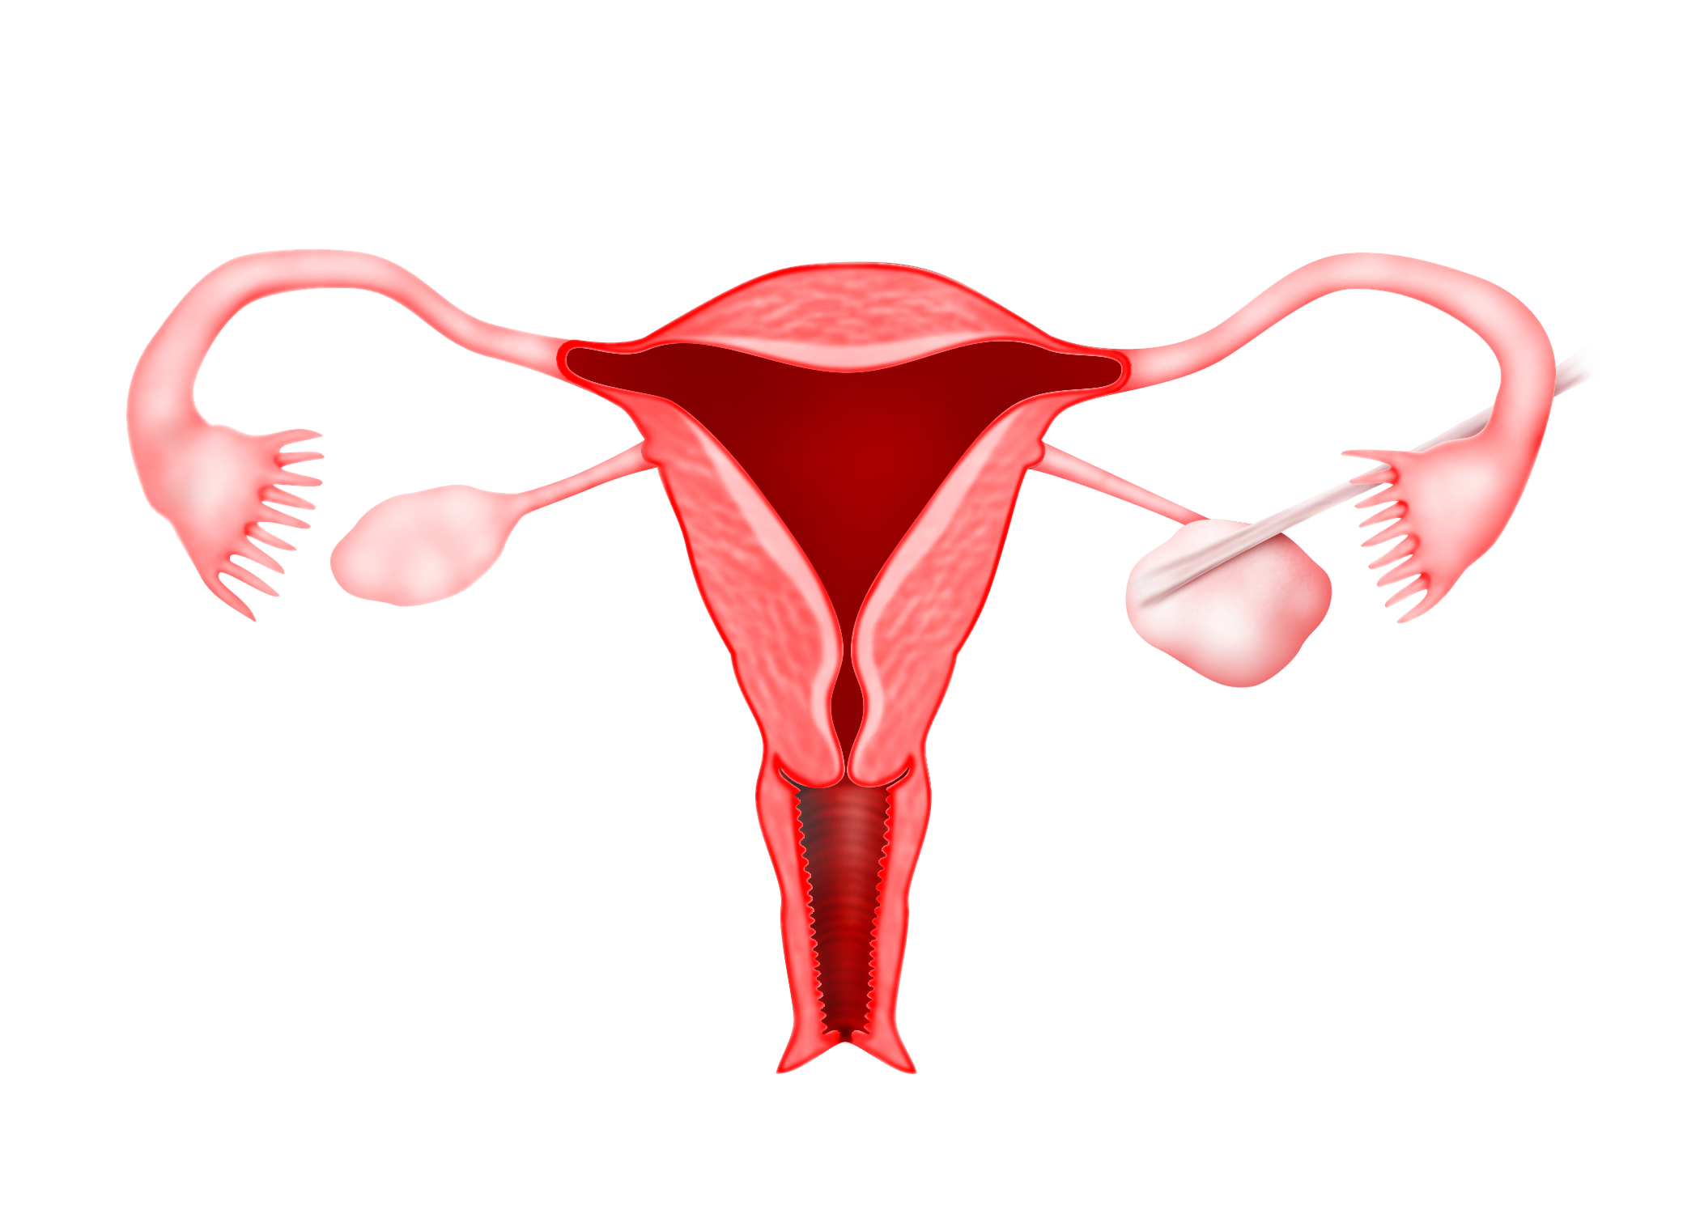
Figure 2: Torsion of a Dermoid cyst
In this case the ovary with a dermoid cyst is twisted around its pedicle many times. Untwisting of the ovary was first performed. The ovary was found to be viable and so only removal of the cyst called a cystectomy was performed. The ovary was thus saved.
In this case the ovary is already gangrenous and not viable because the patient came to the hospital late. So the ovary had to be removed. This surgery is called salpingoopherectomy.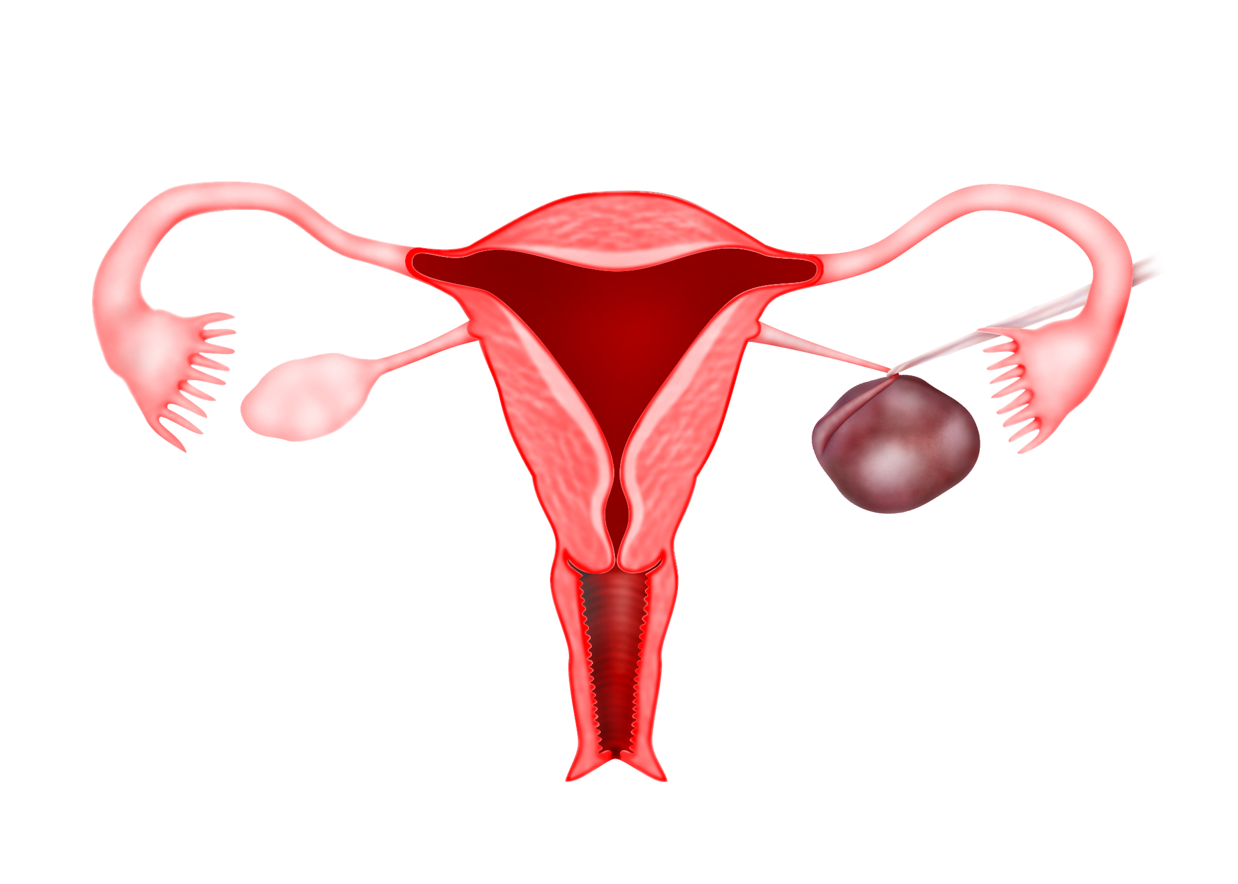
Figure 3 : When the diagnosis of a twisted dermoid cyst is delayed, blood supply to it will be distrupted. This may lead to a grangrene. When this happens, the ovary may need to be removed.

2. Pain can be caused by rupture of a dermoid cyst. The contents of a dermoid cyst can cause irritation in the abdomen causing pain. Immediate surgery is necessary. This is not common.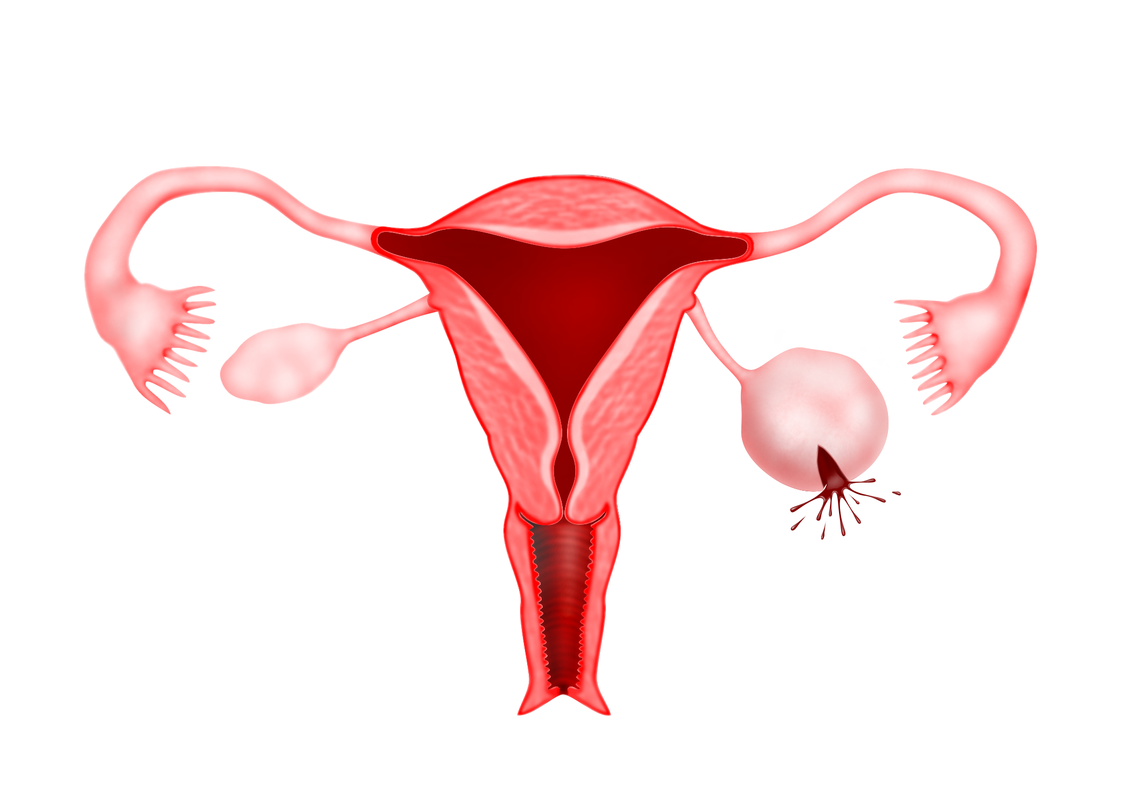
Figure 4: Rupture of a Dermoid cyst can cause pain
3. Sometimes pain is caused by infection of the cyst. The patient my have fever. Surgery is necessary to drain any puss in the cyst and the cyst will be removed
4. Rarely, a dermoid cyst may be malignant and causes pain
How is it diagnosed?
Dermoid cysts are usually diagnosed during a routine ultrasound scan. Sometimes a doctor may miss the diagnosis of a dermoid cyst. The reason is that the contents of the dermoid cyst may be such that it is not seen clearly on an ultrasound scan.
This is an example of a dermoid cyst which cannot be seen clearly because its contents are similar to the other contents in the pelvis.
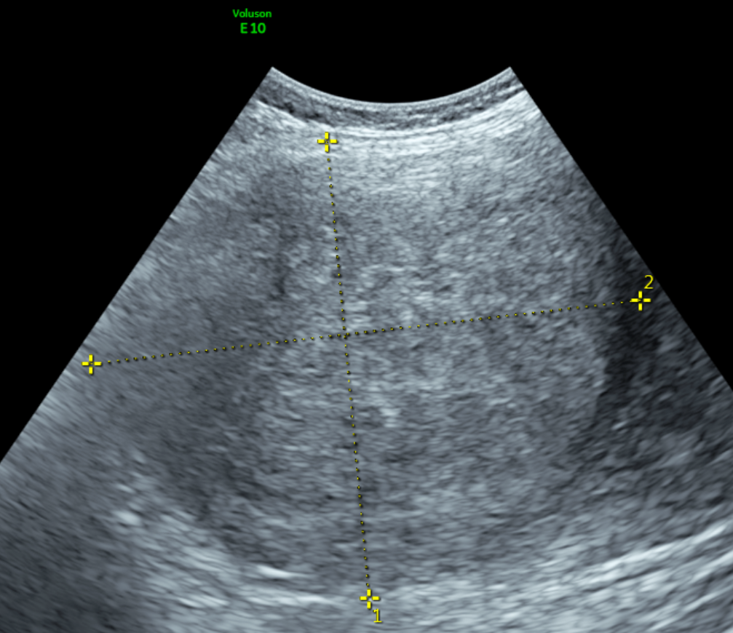
Figure 5: Ultrasound of a Dermoid cyst - Sometimes a dermoid cyst is missed during ultrasound because its contents appear similar to other structures in the pelvis

When a dermoid cyst has fluid and solid tissues like bone of teeth, it can be seen clearly on ultrasound.
In this ultrasound scan, the white areas are the bone and the black areas are fluid in the cyst.
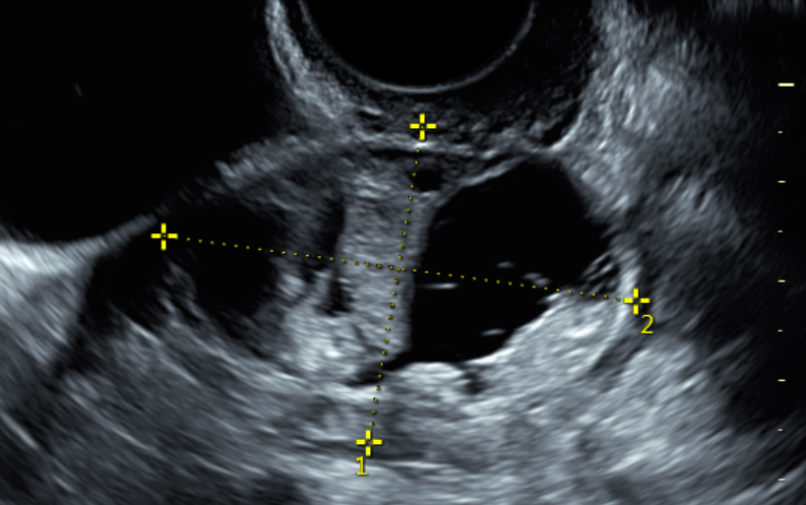
Figure 6: In this utlrasound picture, the dermoid cyst is seen clearly. When the dermoid cyst contains fluid (black in colour) and bone or teeth (white in colour) , it is seen clearly on ultrasound.

In this ultrasound scan, hair can be seen as tiny white lines distributed in the cyst.
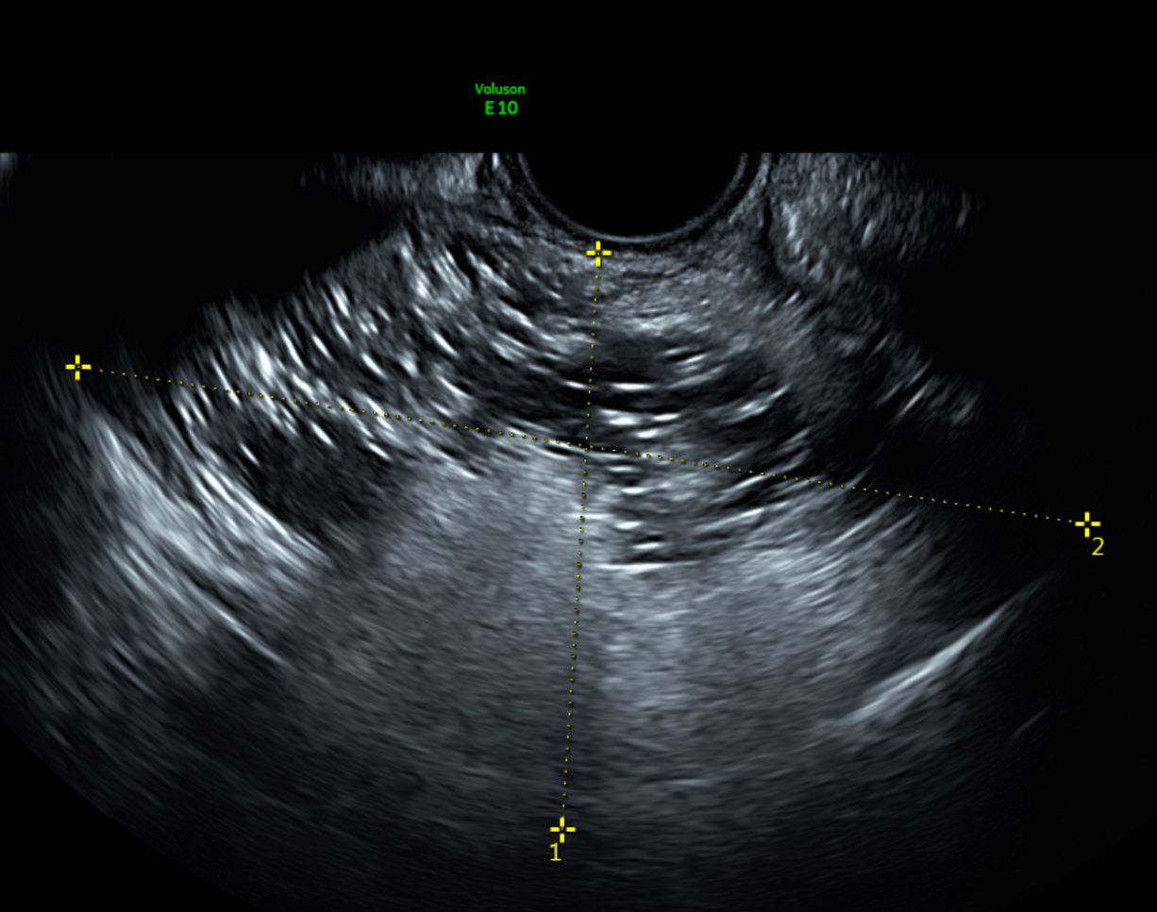
Figure 7 : Ultrasound picture showing hair in the dermoid cyst - hair is seen as tiny lines in the cyst

If the doctor is unsure of the diagnosis, he may order for an Xray or a CT scan. Dermoid cysts are seen clearly on a CT scan of the abdomen and pelvis.
Can a dermoid cyst be a cancer?
Most of the dermoid cysts are benign. However sometimes a cyst that looks like a dermoid cyst may be a cancer called immature teratoma. The difference between a dermoid cyst and an immature teratoma is the type of cells in the cyst. Malignant teratoma is usually seen in younger girls less than 20 years of age. It is very difficult to make a definite distinction between a dermoid cyst and an immature teratoma by blood tests, ultrasound and CT scan. The diagnosis is only made after the cyst is removed and sent for pathological examination

When is surgery required?
There are several situations when surgery is advised.
- Symptoms such as pain and pressure symptoms
- Cyst is larger than 5cm
- Cyst is growing very fast

Surgery is advised when the patient has symptoms. When there is pain surgery should be performed as an emergency. Some patients may have pressure symptoms. When the cyst presses on the bladder the patient might have frequent urge to pass urine. When the cyst presses on the bowel she may have the feeling of always wanting to pass motion.
Surgery is also advised when the cyst is large especially more than 5 cm. If the cyst is smaller than 5 cm and is not causing any symptoms than the patient can choose to wait and see. She will need to see a doctor every 6 months to see whether the cyst is growing in size.
If the cyst is growing fast than surgery will be advised.
How is surgery performed?
There are 2 ways of performing surgery namely:
- Laparotomy
- Laparoscopy
Laparotomy involves a large cut in the abdomen. The cyst is then brought out of the abdomen and usually only the cyst is removed leaving the healthy ovary behind. This surgery is called cystectomy, Sometimes, especially in older women the whole ovary may be removed and this is called salphingooopherectomy.
Laparoscopic surgery involves using 3 to 4 small incisions. The cyst is usually placed in a bag and cystectomy or salpingoophrectomy is performed. The cyst contents are then aspirated and the cyst or ovary is then taken out of a 10 mm incision. Sometimes the patient may have cysts in both ovaries. In this situation the cysts are removed separately in 2 different bags so that there will be histopathological examination of both the cysts separately.
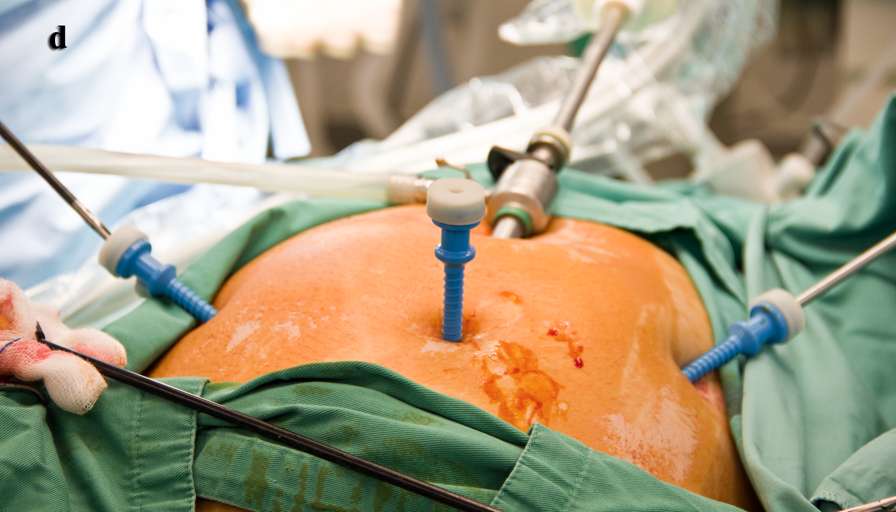
Figure 8: Laparoscopic surgery
Will it recur after surgery?
When a surgery is performed only the cyst that is seen in the ovary is removed. There is a possibility that other totipotential cells are still present in the ovary. These cells may grow at a later date to form another dermoid cyst. So there is always a possibility that the dermoid cyst may reccur.
So after the surgery, the patient will have to undergo regular ultrasound to ensure that another cyst does not grow in that ovary or the other normal ovary. This is the reason why in older women who have completed their family, removal of the ovary may be advised to ensure that no cysts will grow again in that ovary.
Is my ovary destroyed by the cystectomy?
When a cyst develops in an ovary, part of the ovary is already destroyed. The bigger the cyst, the more the ovarian tissue is destroyed. By removing the cyst some part of the ovary will be removed. What remains will be only part of the ovary. However the remaining part of the ovary can still function to produce follicles leading to a pregnancy. When dermoid cysts are present in both ovaries, the surgery must be done carefully because part of both the ovaries has been affected by the cysts.
I would like to further emphasise that it is important to have a regular followup so that if the cyst recurs it can be removed before it becomes large again.
What to do if a dermoid cyst is diagnosed during pregnancy?
Sometimes a dermoid cyst is only diagnosed during pregnancy. When this happens a decision will need to be done whether to perform the operation during the pregnancy or wait until after the delivery to perform the surgery. Elective surgery to remove the cyst is usually done at about 16 weeks or 4 months of pregnancy
There are advantages and disadvantages of both decisions
The advantage of performing the surgery during pregnancy is that one need not worry of the cyst twisting during the pregnancy and undergoing an emergency surgery. Performing an emergency surgery for a twisted ovarian cyst during the late second trimester or third trimester of pregnancy can be difficult.
The disadvantage of performing the surgery during pregnancy is that there is a risk of miscarriage after the surgery.
How can I prevent its recurrence?
It is impossible to prevent the recurrence of a dermoid cyst. The only way is to detect it early during regular ultrasound scans.

Should all dermoid cysts be removed?
In young women, when a small cyst measuring smaller than 5cm is diagnosed as a dermoid cyst, the patient may choose not to do surgery and just wait and see. Regular ultrasound scans can be done and if the cyst remains small and not growing, it may be left alone.
What do you do if a dermoid cyst is diagnosed after menopause?
Sometimes a dermoid cyst is diagnosed after menopause. When an ovarian cyst is diagnosed after menopause, there is always a worry that the cyst could be a cancer. It is very difficult to confirm whether a cyst diagnosed in the postmenopausal age is benign or malignant. So if solid tissues are seen in a cyst in a postmenopausal woman, then surgery is usually advised so as to ensure that a malignant ovarian cyst is not missed.
Any food that can prevent its recurrence ?
Many patients want to know what food to eat or not to eat to prevent occurrence or recurrence of dermoid cyst. Unfortunately, I don't have any advise on this as I am not aware of any food that can prevent the occurrence of a dermoid cyst.

You can watch a video on this topic on youtube by scanning this QR code

